Subnetting Practice 2
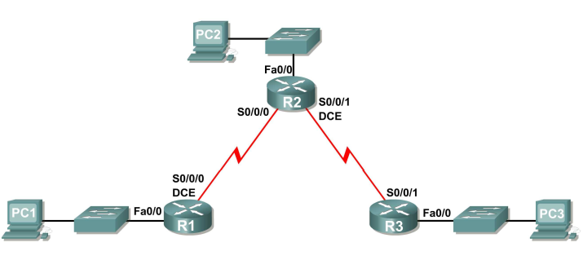
- You have been given the above topology diagram that you need to create. You have been supplied the network address of 192.168.20.0 /26 that you need to subnet to accommodate the above topology.
  - The subnet containing PC1 can have 4 hosts;
  - The subnets containing PC2 and PC3 can have up to 6 hosts each;
  - The WAN link subnets can have 2 hosts each.

Each network will use the same mask.
Complete the subnetting exercise and fill in the below table.

Subnet | Network Address | First Useable Host | Last Useable Host | Broadcast Address
R1–R2 – WAN
R2–R3 – WAN
R1 – Fa0/0 – LAN
R2 – Fa0/0 – LAN
R3 – Fa0/0 – LAN

